Stocks intro

1. Don’t put all your money into trading. Start with a small amount you are comfortable with trading, even if it’s only $100. Never invest money you are not okay with losing.
2. Once you find a stock you are interested in, view their financial records, see how they have been doing in the last couple of years. Yahoo finance is a quick source, however if you want to see a more detailed report, you need to look at the company's 10k.
3. Open an account with a brokerage and connect it with your bank account to transfer and receive money.
   1. Fidelity
   2. Schwab
   3. Robinhood
4. Make long-term investments that you won’t be selling for at least a year. Investing long-term will almost always yield more profit. The price will decrease from time to time, however price tends to go up over extended periods of time as depicted in the Vanguard chart. 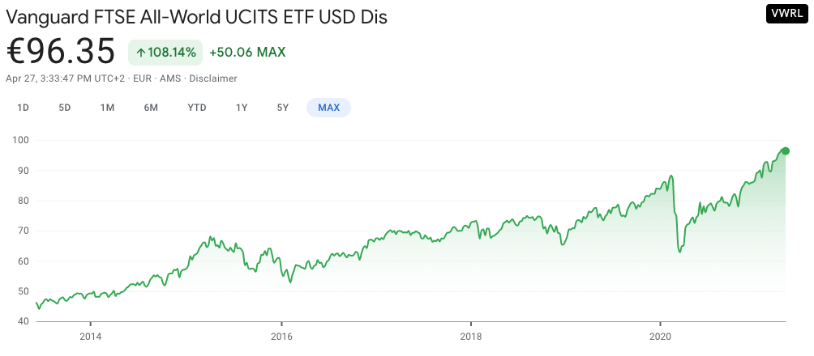
5. Diversify your portfolio. If you invest in primarily technology companies like Apple, Tesla, and Microsoft, and that area fails, so will your investments. If you have a range like retail, technology, entertainment, and bonds, your exposure is limited. One method is investing in an index fund.
   1. SP 500- measures the performance of top 500 companies in US